Beginning Bioinformatics
(Part 1)

Introduction
Bioinformatics is a catch-all term for research at the intersection of computer science and biology. Courses in bioinformatics vary widely based on the types of students in the course. This course was designed for biologists who have little, or no, programming experience, and over time it has also drawn students from engineering and data science. All are welcome.
Learning to program a computer is not unlike learning any other language. First you learn to read and mimic, gradually learning vocabulary (commands) and grammar (syntax), until at some point you start to speak (write your own code). Becoming fluent takes time, practice, and patience.
Large Language Models (LLMs) and other AI tools can help with this process. They can draft code, explain error messages, and suggest alternatives. But they do not understand your data or goals unless you state them clearly, and they can be wrong in subtle ways. Computers are still literal, and if your commands and syntax are off, the machine is utterly clueless about what you are trying to tell it to do. You can be one semicolon away from making a script work flawlessly and all you get is an obscure error notice, or nothing at all. As you will find out, this can be frustrating; my principal advice is to be patient. We will learn techniques to debug your code, to write clear prompts when you use AI, and to verify results on small test cases. When you get frustrated, take a break and walk away. Errors, especially small ones, are often easier to find after coming back with fresh eyes.
For many biologists it is not necessary to be fluent to be functional, but the more fluent you become the more likely you are to find interesting and creative ways to approach computational aspects of your research.

Why learn to program (in the age of LLMs)?
It’s fair to ask: if AI can write code and there are many point-and-click tools, why learn to program at all? A few reasons matter more now than ever:
- Sharper scientific thinking. Turning a biological question into precise, testable steps is core to good science. Programming, and writing unambiguous AI prompts, forces you to define inputs, outputs, assumptions, and checks. That habit transfers directly to wet-lab troubleshooting and study design. Whether or not this class turns you into a “programmer” and sets you on a path to becoming a computational biologist, learning to think at the level of precision necessary to communicate with a computer will make you a better scientist, not just a better computer user. For example, if you learn to debug code, you should be able to troubleshoot PCR!
- Reproducibility and auditability. Code is a recipe; prompts and parameters are part of the method. If you can read and write scripts (and keep a prompt log), you can show exactly what you did, re-run it, and let others verify it. That is just a good way to do science!
- Customization and edge cases. Standard tools cover common analyses; your project’s quirks are rarely “standard.” Programming lets you adjust formats, fix boundary conditions, or combine steps in ways menus won’t.

- Quality control with AI. LLMs are excellent assistants but imperfect scientists. Knowing how to code lets you:
  - write clearer, more testable prompts
  - validate outputs with tiny, known examples
  - spot hallucinations and silent failure modes
  - ask for alternatives and justify choices
  - more efficiently recognize and deal with edge cases in your data
- Data stewardship & ethics. Understanding what your code and tools actually do helps you respect privacy constraints, avoid leakage or bias, and document limitations—especially when AI systems are involved.
- Career resilience. Tools change. Conceptual understanding of file processes, formats, reproducible workflows will travel with you.

In this course will treat AI as a lab partner and tutor, not as a genius on whom we can offload our effort and thinking.
By the end of the course you should be comfortable moving between biological questions, Unix and Python basics, and AI-assisted coding; confident enough to use modern tools, and careful enough to trust the results.


Why learn Unix if we have Open OnDemand?
Open OnDemand gives you a browser-based way to reach remote resources (file manager, app launchers, web terminal, Jupyter/RStudio), but Unix is how you get real control over data and jobs once you are there.
What OnDemand provides
- Launchers for Jupyter, RStudio, and other apps
- A file manager for upload/download and basic edits
- A web terminal to the same Unix environment used by jobs
When the Open OnDemand GUI is enough
- Quick file upload/download/organization
- Spinning up a notebook or integrated development environment (IDE) for exploratory work
- Inspecting small files
What Unix adds (that GUIs can’t match)
- Scale & automation: Loop over and manipulate hundreds of files, submit arrays, and script repeatable steps.
- Composability: Chain tools with pipes to avoid temporary files and speed I/O.
- Reproducibility: Shell history, scripts, and Makefiles/Snakemake record exactly what ran; easy to re-run and share.
- Portability: The same commands work across clusters, containers, and cloud VMs—not just in this portal.
- Troubleshooting: Logs, environment modules, and CLI options make it easier to see what went wrong and fix it.
- Data movement: Reliable transfers and sync with rsync, wget/curl, Globus CLI (where available).

As you will see in the tutorials that follow, Unix can do some very useful bioinformatics just by piping simple commands together.
Bottom line: OnDemand is the doorway; Unix is how you work once inside—at scale, reproducibly, and with enough precision to trust your results.

Introduction to Unix/Linux essentials
The following series of Tasks is meant to introduce and make you comfortable working from the Unix terminal command line. Although the vocabulary of Unix is large (hundreds of commands, many with multiple options and unique syntax) you can accomplish the vast majority of what you need to do with only the ~20 or so commands in this tutorial.

U1: The Terminal
A ‘terminal’ is the common name for the program that does two main things. It allows you to type input to the computer (i.e. run programs, move/view files etc.) and it allows you to see output from those programs. All Unix machines will have a terminal application.

TASK U1.1 Open a Terminal window on Bridges-2 in your browser

Navigate to https://ondemand.bridges2.psc.edu/ and login with your PSC credentials. The Dashboard (below left) will show a variety of shortcuts to common applications. Select the “Bridges-2 Shell Access” icon. This should open a new tab where you will be prompted again for your password. Note that as you type in your password, the cursor will not move and you won’t see any characters appear. You should now see a new terminal window that looks similar to the image below (right).
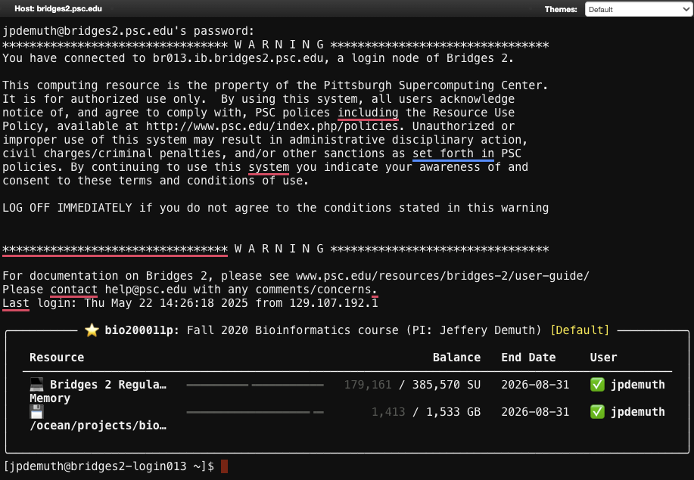
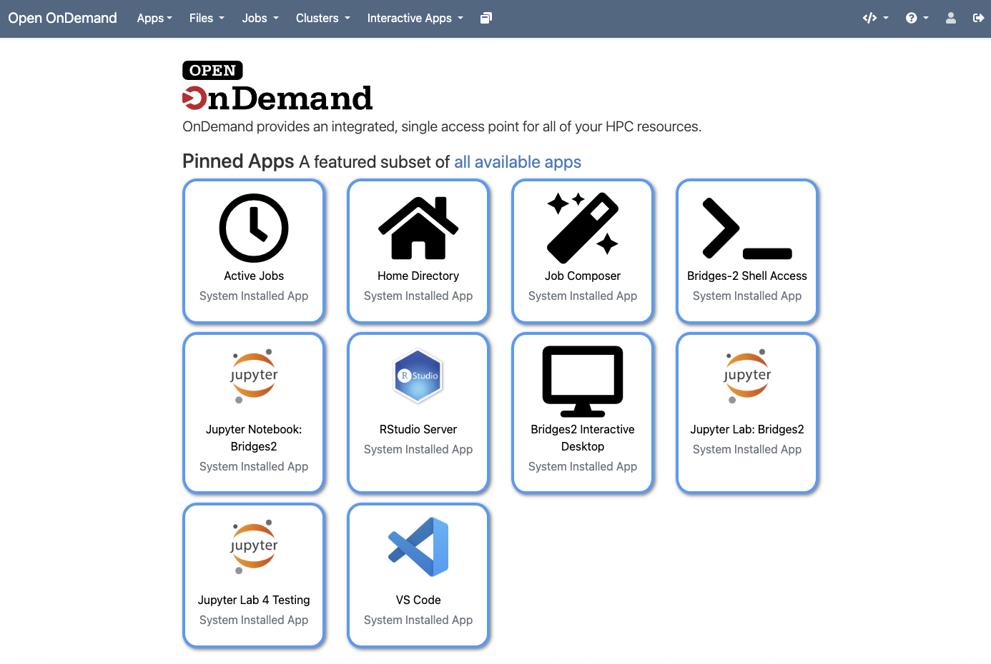
The look of the Terminal window, and the command line prompt are highly customizable. I encourage you to explore variations on the default theme, but for now we’ll leave it as the Default.
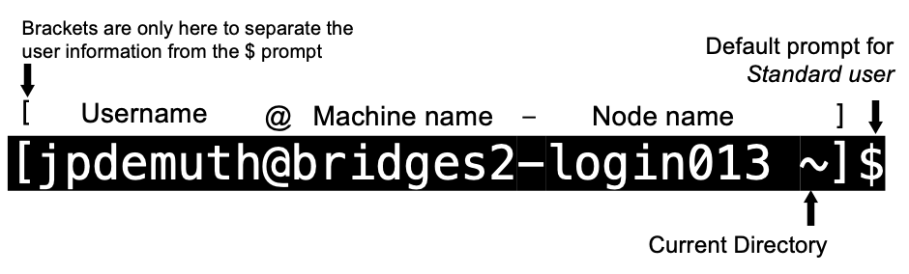
The default terminal prompt the shows the following information:

U2. ls – ‘list’ files in working directory

The two main benefits of learning to access and manipulate files via the Terminal are: 1) there is often no GUI available when working on remote computing resources, and 2) automating actions on multiple files. Before we can appreciate these benefits, we’ll need to learn how to navigate the Unix file structure via the command line.
From the terminal, to see what files are in our current “working directory”, we need to use the ls command. This command ‘lists’ the contents of a directory. So why don’t they call the command ‘list’ instead? Well… it’s half as much typing, and less typing is better! There are many frequently used Unix commands that are just two or three letters.

Task U2.1 Run the ls command to list the contents of your Home folder.
You should see something like:
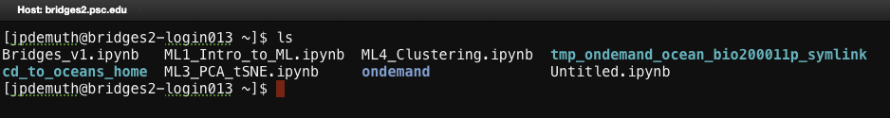
(Your output will vary depending on the actual contents of your home folder)
There are a few things to note here:
- The default theme on Bridges-2 colors outputs according to their type (files, directories, links).
- After the ls command finishes it produces a new command prompt, ready for you to type your next command.
The ls command can be used to list the contents of any directory, not just the one that you are currently in.

U3: Finding your path through the directory hierarchy
Navigating directories from the Unix terminal may seem confusing at first, but it may help to think of it as a branching set of nested folders (directories) that starts at the “root” /

Ask ChatGPT…

Copy/Paste, or take notes on the AI response below for future reference. Include any follow up questions you may have related to the AI response.

Task U3.1 Do-this-now checks (OnDemand Web Terminal)
Try typing the following lines in your terminal prompt.

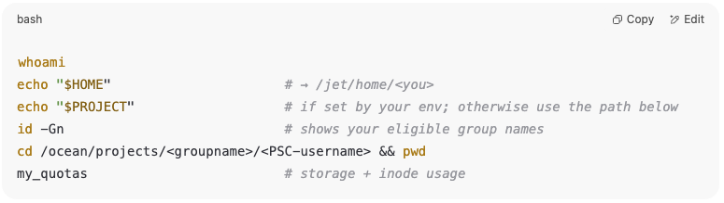

U4: cd – change directories
If you actually want to “move” to a specific directory (i.e. make it your working directory) rather than just list its contents, you use the cd (change directory) command instead of ls.

TASK U4.1 Use cd to move to your $PROJECT directory

Remember: The working directory is shown inside the brackets of the default command prompt. After changing directories in the task above, your prompt should look something like… [jpdemuth@bridges2-login012 jpdemuth]$ but substituting your username instead of jpdemuth (my username). This feature of the Linux command prompt is useful because it reminds you where you are as you move through different directories on the computer.

Not sure where your current working directory is in the overall directory structure? Move on to the next task to find out how to

Pro Tip: If you type cd by itself with no destination specified, you will automatically be returned to your $HOME directory.

U5: pwd – Print Working Directory
If you ever need to know where you are in a Unix/Linux system’s directory structure, the pwd command will always tell you the absolute path to where you are in relation to the root (/).

TASK U5.1 print the working directory for the $PROJECT directory
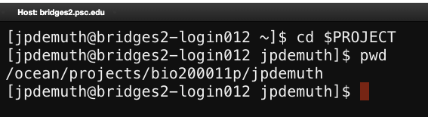

U6: Use cd alone to go straight $HOME (~)

TASK U6.1
See what happens when you try the following commands (use the pwd command after each one to confirm the results):
cd /
cd ~
cd /
cd
cd $HOME
You should find that cd and cd ~ and cd $HOME all do the same thing, i.e. they take you back to your home directory (from wherever you were). Also notice how you can specify the single forward slash to refer to the root directory of the computer. When working with Unix you will frequently want to jump straight back to your home directory, and typing cd is a very quick way to get there.
Remember that the command prompt shows you the name of the directory that you are currently in. Have you noticed that when you are in your home directory it shows you a tilde character (~) instead? This is because Unix uses the tilde character as a short-hand way of specifying your home directory. Starting a path with ~ can be a useful shorthand way to specify the relative path from your home directory rather than the absolute path from the root.

Pro Tip: The ls command can work with paths too! It will list the contents of the path rather than move you there.

LETS GET SOME DATA!

U7: Use the Open OnDemand file browser to move files onto Bridges-2 (Home)
- Download from Canvas to your computer
Save Data.tar.gz locally.
- Go to your Bridges-2 Open OnDemand Dashboard page
Sign in to the web portal again if necessary
- Click the Home Directory icon on the dashboard
In the top bar. You should see a path like /jet/home/<your_username>
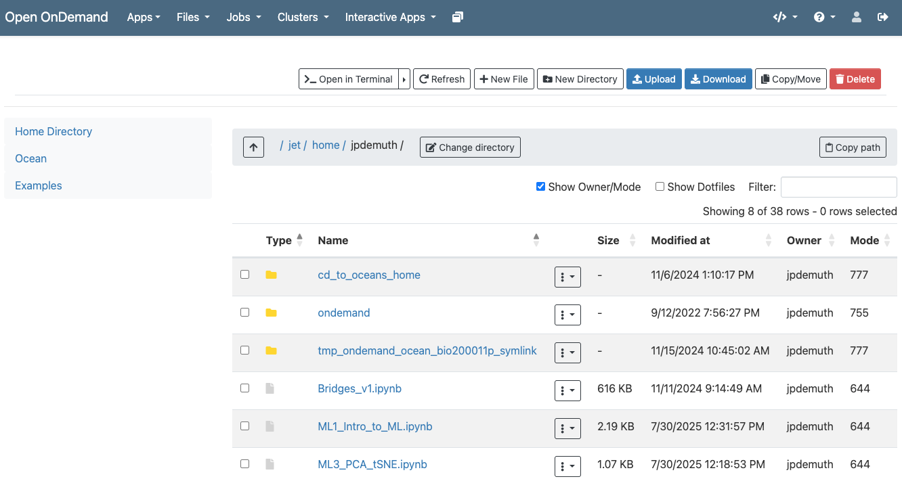

- Upload the file
Either: Drag and Drop the file from your local machine one the file browser window, OR Click Upload, choose Data.tar.gz and then wait until it finishes and confirm it appears in the listing.

U8: tar – “tape archive” to extract and compress files
One of the major computational challenges posed by the rapidly escalating capacity of high-throughput DNA and RNA sequencing capacity has been the inability to efficiently move and share data among research collaborators and sequencing core facilities. The tar command is used both for compressing (i.e. packing, zipping, archiving) and extracting (i.e. unpacking, unzipping) files. For now, we will focus on extracting files that have already been compressed.
The Data.tar.gz file ending “.tar.gz” is a very common pair of file extensions for compressed files and is referred to as a tar file or tarball. The extra .gz extension indicates that the gzip method has been used to compress the tar file.

This command extracts the contents of the tar file into your current working directory, which in this case is your Downloads folder. The letters after the hyphens are common parameters used with the tar command. They mean: x extract, z uncompress with gzip, v verbose mode (i.e. list each file as it is extracted), f indicates the file to unpack.
Since we used the verbose option, you should see a list of the files being unpacked. Use ls to confirm that the Data directory is now in your Home directory.
Note: To extract files to any directory you can use the -C option and then specify the path to the location where you want the extracted content to go.

TASK U8.1 – Extract the Data.tar.gz archive to your Home directory
- In your terminal window navigate to your Home directory
- Execute the following command: tar -xzvf Data.tar.gz
- Use cd and ls to explore the contents of what you just extracted

TASK U8.2 – compress the Arabidopsis directory
- Navigate to the new Data directory you just created (should be ~/Data)
- Execute the following command: tar -czvf Arabidopsis.tar.gz Arabidopsis
- Use ls to see what happened
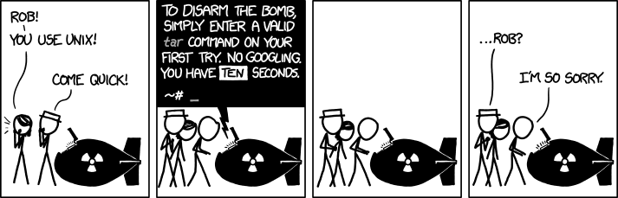
This command is almost the same as extraction but the -x (extract) is replaced with -c (compress) and we must give the new archive file a name (Arabidopsis.tar.gz) followed by the original file or directory name (Arabidopsis).

U9: Absolute paths – start from the root ( / )
An absolute path begins with / and is interpreted from the filesystem root. On Bridges-2 this matters because your code and your data often live in different places (e.g., code in your home directory on Jet, data in project space on Ocean). An absolute path like /ocean/projects/<group>/<username>/data/sample.fa works no matter where the command runs (e.g a terminal, a Jupyter notebook, or a batch job submitted using SLURM…which we’ll get to later).

Why you’ll need absolute paths on Bridges-2
- Home vs Project storage: code/scripts in ~ (Jet) and data in /ocean/projects/... (Ocean) are in very different locations.
- Jupyter notebooks: notebooks may launch with a different “current folder” than you expect.
- Batch jobs: Your SLURM batch scripts may live in a different location than the software and data it uses. To ensure the job runs correctly from anywhere, you should specify absolute paths to every required resource (e.g., /ocean/projects/<group>/<user>/..., /jet/home/<user>/...) so the script can fully execute regardless of where the SLURM script is stored and submitted.

TASK U9.1 – Practice navigating using relative paths
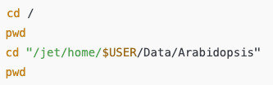
Try these:

U10: Relative path – use two dots .. to visit the parent directory (i.e. up one level)
Frequently, you will find that you want to go “up” one level in the directory hierarchy. Two dots .. are used in Unix to refer to the parent directory of wherever you are. Every directory has a parent except the root level of the filesystem.
A relative path is interpreted from where you are now.
. one dot = the current directory
.. two dots = the parent directory (one level up)
What if you wanted to navigate up two levels in the file system in one command? It’s very simple, just use two sets of the .. operator, separated by a forward slash: ../..

TASK U10.1 – Practice navigating using relative paths
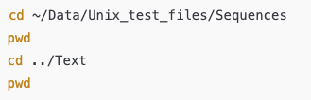
Try these:

U11: Press Tab to complete - type less and stay on path
The ***BEST Unix TIP*** to learn early on is that you can tab complete the names of files, directories, and many programs.
Saving keystrokes may not seem important, but less typing means less opportunity for typos.
Type enough letters that uniquely identify the name of a file, directory or program and press tab… Unix will fill in the rest. For example, if you type tou and then press tab, Unix will autocomplete the program named touch (which we will learn more about later). In this case, tab completion will occur because there are no other Unix commands that start with ‘tou’.
If pressing tab doesn’t do anything, or only partially completes a name, then you have not typed enough unique characters. In this case, pressing tab twice will show you all the options that match what you have typed so far. This trick can save you a LOT of typing. It can also help you keep track of where you are in the directory structure and save you when you forget the exact file name or spelling.
As you learn Unix you will frequently type commands that don’t seem to work. The most common problem is that the path is wrong and the computer can’t find the program or file you think you’re telling it to act on.
One way to help make sure you stay on the right path is to use tab complete.

TASK U11.1 Practice using cd and tab complete to navigate directory contents.
- What is the minimum number of keystrokes needed to get from your home directory to the Sequences subdirectory inside the Unix_test_files directory inside the Data directory?

U12: history can save you time
The ***SECOND BEST Unix TIP*** to learn early on is that you can use the up and down arrows to cycle through previous commands.
Another great time-saver is that Unix stores a list of all the commands that you have typed in each login session. You can access this list by using the history command or more simply by using the up and down arrows to access anything from your history. So if you type a long command but make a mistake, press the up arrow and then you can use the left and right arrows to move the cursor over to make a change rather than retyping the whole command.

TASK U12.1 Try using history to see your previous commands
Type the following into the terminal. You may have to scroll up to see the compete output.
history
history 5

What happened?

TASK U12.2 Execute a command from your history by typing ! followed by its number.
For example, typing !4 at the prompt will execute the 4th command from the beginning in your history

Try pressing Ctrl + r and then start typing a previous command.
Ctrl + r searches for commands in your history that match what you type and fills them in at the prompt.

U13: Use ls -l to display info about files & directories
The ls command (like most Unix commands) has a set of options that can be added to the command to change the results. Command-line options in Unix are specified by using a dash (‘-’) after the command name followed by various letters, numbers, or words. If you add the letter ‘l’ to the ls command it will give you a ‘longer’ output compared to the default:

Object types: - = file; d = directory, (sometimes you will see l = link, but it’s more rare)
Permissions: There are 3 sets of 3 columns to represent the read(r), write(w), and execute (x) permissions for the owner, group, and other users.
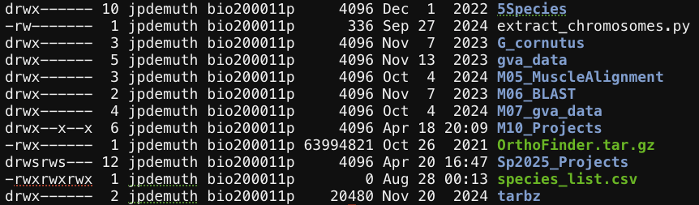

# of links
Owner
Group
Date last modified
Size (bytes)
Name
(Colors represent types and permissions)
Object Type
Permissions

TASK U13.1 Experiment with ls command options
There are many, many different options for the ls command. Try out the following (against any directory of your choice) to see how the output changes.
Note that the 4th example combines multiple options but only use one dash. This is a very common way of specifying multiple command-line options.
Bridges-2 shell has some built-in shortcuts (aliases) try
“ll” and “la”
ls -l
ls -R
ls -l -t -r
ls -lh

Using what you’ve learned so far, try to figure out how much space was saved by compressing the Arabidopsis folder.

U14: less – view file contents one “page” at a time.
The bracket [ ] notation used here is common in Unix documentation. The bracket contents are command options to be filled in by the user. In this case you would substitute [filename] with the name of the file you want to open with less.
To view (but not edit) the contents of a text file in Unix, open the file by typing less [filename]

The less command will send the contents of the file to the terminal one screen at a time. While viewing a file in less the prompt will appear as a colon “:” and allow you to specify navigation and searching options interactively. Scroll forward one page by pressing space, or go forward or backwards one line at a time by using the arrow keys. Pressing h (for help) will display the complete list of options. Press q (for quit) to exit less and return to the regular command prompt.

The less program also does many other useful things (including text searching). Later we’ll see how less can even be used to display the results of other commands!

TASK 14.1 Use less to find out the accession numbers for the first three proteins in the Arabidopsis thaliana protein sequence file ~/Data/Arabidopsis/At_proteins.fasta
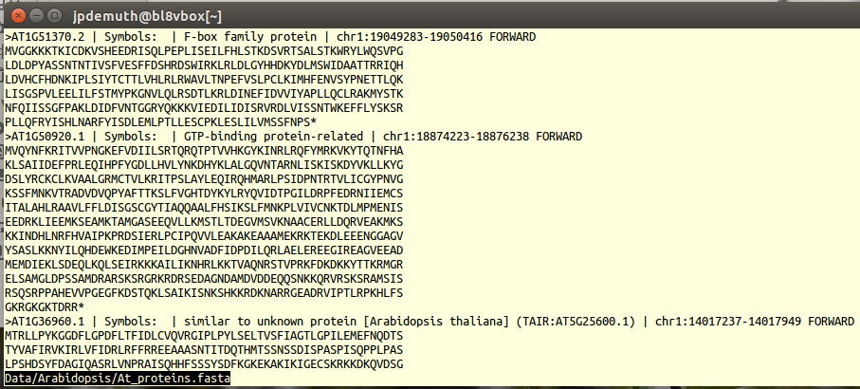
The first page of less should output:

U15: head and tail – view the beginning or end of a file
Sometimes we only want to see the first or last few lines of a file. For example you may just want to check whether a fasta file has DNA or protein sequence in it. There are two useful Unix commands for doing this:
head [filename] Show the first 10 lines of “filename”
tail [filename] Show the last 10 lines of “filename”
By default these commands only show 10 lines of a file. To specify a different number of lines you can add –n (where n is the number of lines you want to display) before the filename. For example, head -2 At_proteins.fasta would display only the first two lines of the file.

TASK 15.1 Use head to find out whether chr1.fasta contains DNA or Protein data (~/Data/Arabidopsis/chr1.fasta)

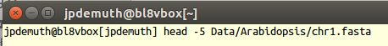

A FEW WORDS OF CAUTION ABOUT FILE SIZE
The protein sequence file we just opened is small (only ~18MB). For files this small, using a text editor is a perfectly valid option for opening the file. However, modern genome sequencing files can be far larger than the total amount of RAM on any normal desktop or laptop computer. Trying to open a 20GB file with your system’s default text editor is an easy way to “crash” your computer. You should get used to using less, head and tail, to see what is in a file without bringing your system to a screeching halt.

U16: grep – find text in files
You will often want to search files to find lines that match a certain pattern. The Unix command grep does this (and much more).
The .fasta files we’ve already looked at are examples of one of the most common formats for sequence data files in bioinformatics. They have a simple format: one header line which always starts with a ‘>’ character, followed by a DNA, RNA or protein sequence on subsequent lines.
To find only the header lines in a FASTA file, you can use grep.
The format of a grep command is grep [options] “pattern” [filename…] where “pattern” is the string you want to search for in one or more files. There are many powerful [options] available for grep. We will explore a few, but if you ever want to see a full list you can use grep --help.

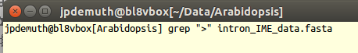
TASK 16.1 Use grep to list only the headers in intron_IME_data.fasta

This should produce lots of output and every line should start with a “>”

TASK 16.2 Use grep to show only the sequences in intron_IME_data.fasta
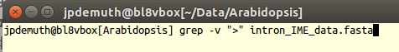
One common option is to get grep to show lines that don’t match your input pattern. You can do this with the -v (inverse) option.

This should produce even more output than the previous task but only the sequences should be shown (no headers).

U17: | – use “pipe” to connect commands
The output of grep in the previous exercise wasn’t all that useful because most of the text streamed by before you could look at it. Fortunately, Unix makes combining commands easy, so we can send the output of grep into another command (e.g. less) to control the output. To do this you simply “pipe” the output from one command into the next command by putting the pipe character “|” between them. In fact, you can connect any number of commands (or programs) this way as long as the output from each command is appropriate input for the next command in the series.

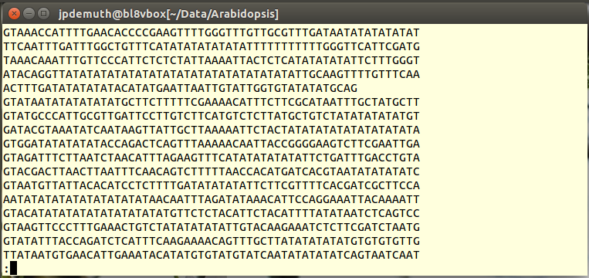
TASK 17.1 Pipe grep into less to explore how many lines contain the AT(5) microsatellite in intron_IME_data.fasta
Note: it doesn’t matter if you put spaces before/after the pipe character

Notice that the result of this pipe leaves you in the less program, giving you control of your output.

Highlighting results in less:
If you press the forward slash (/) key in less, you can then specify a search pattern. Type ATATATATAT after the slash and press enter. The less program will highlight the location of these matches on each line. Notice that it finds some matches that are much longer than AT(5) because search is sliding one character at a time and AT(5) is “true” along several contiguous blocks. Technically “/”searches forward from whatever point you are at in the file, but you can also search backward using question-mark ?
WARNING - grep matches patterns on a per line basis. So in this example, if one line ended ATAT and the next line started ATATAT, then grep would not find a match to AT(5).

U18: Using grep to search across multiple files
So far we have only used grep to search within a single file, but it can also search for a pattern across multiple files. The format of the grep command is the same except that you use a wildcard character (e.g. * or ?) in the filename to match multiple files.
grep -i: ‘ignore’ case when searching. If you aren’t sure whether the text you’re searching for is in upper-case or lower-case, or you want to return matches for both cases, then use the -i option of grep

TASK 18.1 Search for the pattern “ACGTC” across all the files in the Arabidopsis directory. Use head and tail to only report the first 10 lines and the last 10 lines of results.
grep –i “ACGTC” * | head
grep –i “ACGTC” * | tail
How does the output differ from the output of previous grep commands that searched only one file?

U19: Introduction to regular expressions with grep
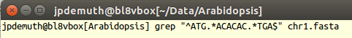
A concept that is supported by many Unix programs and also by most programming languages is that of using regular expressions. These allow you to specify search patterns which are quite complex and really help restrict the huge amount of data that you might be searching for to some very specific lines of output. For example, you could find lines that begin with a start codon (ATG), end with a stop codon (TGA), and also have at least three AC dinucleotides in the middle with a regex that looks like this:
The ^ character is a special character that tells grep to only match a pattern if it occurs at the start of a line. Similarly, the $ tells grep to match patterns that occur at the end of the line.

TASK U19.1
The . and * characters are also special characters that form part of the regular expression. Try to understand how the following patterns all differ. Try using each of these patterns with grep against any one of the sequence files. Can you predict which of the seven patterns below will generate the most matches? We will test your predictions below.
ACGT
A..T
AC*T
AC.GT
AC*GT
AC.*GT
A*C*G*T*

The * in a regular expression is similar to, but NOT the same, as the other asterisks that we have seen so far. An * in a regular expression mean, ”match the preceding character or pattern zero or more times”.

When searching in less you can also specify regular expressions.

TASK U19.2 Pipe the grep statement above into less and then search for the patterns “ATG.*TGA$” and “ATG*TGA$”
This should make it easier to see exactly where your regular expression pattern matches. After typing a / (or ?), you can press the up and down arrows to select previous searches.

ChatGPT can help A LOT with designing regular expressions!

U20: grep -c – Counting with grep
Rather than showing you the lines that match a certain pattern, grep can also just give you a count of how many lines match. This is one of the frequently used grep options. Running grep -c simply counts how many lines match the specified pattern. It doesn’t show you the lines themselves, just a number:
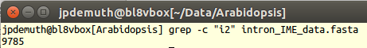

TASK U20.1
Count how many times each pattern from TASK U19.1 occurs in all of the sequence files (specifying *.fasta will allow you to specify only the sequence files).

U21: tr – translate a set of characters
We have seen that these sequence files contain upper-case characters. What if we wanted to turn them into lower-case characters (because maybe another bioinformatics program will only work if they are lower-case)? The Unix command tr (short for translate) does this, it takes one range of characters that you specify and changes them into another range of characters:

Format tr [options] “set 1” “set 2” < filename
- tr a b – will translate individual character “a” into “b” in the text used as input.
- tr “A-Z” “a-z” – will change each element in set 1 into the corresponding element of set 2. In this case all uppercase letters to lowercase.
- tr -d “set1” – will “delete” matches to set 1. Used without specifying a set 2. (e.g. tr –d “0-9” would delete all digits from the output)

The Unix language, like all languages, has some quirky things about it. One of these quirks is that for some commands, like tr, you can’t just specify a filename to act on like you can with less, head, tail and most others. Instead you need to use the “read file” redirect (<). The < redirect literally means “read the file on the right as input for the command on the left”. Knowing when you need to use this redirect is a little like native English speakers trying to learn which form of “the” to use in languages with gender specific articles. You just have to learn it and eventually you hope it starts to “sound right”. If you need < and don’t use it, you’ll probably get an error. If you don’t need one and you use one anyway the command will often work normally (e.g. less, head, tail, sort all work with or without <).
Also note that when you pipe an output into the tr command, you do not use <
For example: head -1 chr1.fasta | tr C X This will return the first line of the file with all “C”s replaced by “X”s.

TASK U21.1 Return the first two lines of chr1.fasta in all lower-case format

Of the 2 possible solutions to this task using tr and head, which is more computationally efficient? (i.e. is it better to pipe tr into head, or head into tr?)

U22: sed – stream editor; like grep but with edit powers
The tr command let’s you change a range of characters into another range. But what if you wanted to change a particular pattern or word into something completely different? sed is a very powerful Unix command capable of performing a variety of text manipulations such as: searching, find and replace (substitute), insertion or deletion.
Format sed “s/pattern-to-find/replacement-pattern/” [filename]
The ‘s’ part of the sed command puts sed in “substitute” mode, where you specify one pattern (between the first two forward slashes) to be replaced by another pattern (specified between the second set of forward slashes). If used in a pipe, sed will take input from the previous command, so you don’t need to specify a filename to act on.
Just as tr had the quirky syntax of requiring the readfile redirect (<), sed has the quirk that it reads input files line by line and acts on them individually. Therefore, sed has difficulty recognizing patterns that include a newline character (“\n”) or span across lines.
Note: as long as the output of the command is going to the terminal (it does this by default) then sed doesn’t actually change the contents of the file, it just changes the screen output. Later we will learn how to redirect the output from a command into a new file.

TASK U22.1 Change the first word of the first header in chr1.fasta to “Chromosome 1”

Things to consider:
What is the pattern we are trying to match (what goes between the first two slashes?)
How can we do this most efficiently (i.e. only evaluate the line we want to edit)?

“global substitution”
WARNING - By default sed only acts on the first occurrence of a pattern in each line. To replace ALL occurrences in a file you add the “g” option for “global substitution” to the end of the command like this
sed “s/pattern/replacement/g”

U23: wc – “word count” to count lines, words, and bytes
For this section we’ll work with a different type of file. It is sometimes good to get a feeling for how large a file is before you start running lots of commands against it. The ls -l command will tell you how big a file is, but for many purposes it is often more desirable to know how many lines it has. That is because many Unix commands like grep and sed work on a line by line basis. Fortunately, there is a simple Unix command called wc (word count) that does this:

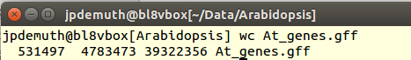
TASK U23.1 Run wc on the gff file in Arabidopsis

The three numbers in the output above count the number of lines, words and bytes in the specified file(s). If we had run wc -l, the -l option would have shown us just the line count.

For other wc options you can run wc --help

U24: Redirect to > – “write file” or >> – “append file”

The standard output (stdout) for commands run in the terminal is to send the output back to the screen. With pipes we can temporarily redirect output into another command, but what if you ultimately want to save output to a file? Unix makes it easy with the “write file” (>) redirect operator. Just put > and a filename at the end of your command line and Unix will write the output to that file. Paths can also be specified if you want the file to be written in a different directory than you current working directory.
WARNING: the write redirect will overwrite a file with the same name without warning!
If you want to append output to the end of an existing file without overwriting the data that is already there, use the “append file” redirect operator “>>”

In addition to the .fasta sequence files, the Arabidopsis directory also contains a GFF file. This is a common file format in bioinformatics used to describe the location of various features on a DNA sequence. Features can be exons, genes, binding sites, etc, and the sequence can anything from a single gene to a whole genome.
The GFF file in At_genes.gff contains information for all of the gene-related features from Arabidopsis thaliana (a plant model system). We want to play around with some of this data, but we want things to run quickly… so 10,000 lines will do (rather than the ~500,000 lines in the original).

TASK U24.1 Use head and > to create a new GFF file that contains only the first 10,000 lines of the original. Name the new file Subset_At_genes.gff

What if you wanted a subset file that had only the first 5,000 lines of the original file, but had each line twice (i.e. 10,000 total lines)?

WARNING – DO NOT MIX UP < (read file) and > (write file)!!!!
If you accidentally do write file when you meant to do read file, you will overwrite the file you were trying to read without warning. This typically leaves you with a blank file where your data used to be!

***PRO TIP*** protect your data by creating a copy before working on it directly.
If you have a large data file, also consider creating a subsample to test if your scripts generate the desired output before you try running it on the full data.

U25: Use cut, sort, uniq to parse a GFF file
As already mentioned, the GFF file that we are working with is a standard file format in bioinformatics. For now, all you really need to know is that every GFF file has 9 fields (columns), each separated with a tab character. There should always be some text in every column (even if it is just a dot “.” character).

The 2nd and/or 3rd fields of a GFF file are usually used to describe some sort of biological feature. In At_genes.gff (and our subset file) field 2 has source names and field 3 has feature types.

TASK U25.1 List each of the unique feature types in Subset_At_genes.gff
To do this efficiently we’ll pipe 3 new commands together: cut, sort, and uniq:
- cut reads each line and cuts it on tabs by default (–d option lets you specify different “delimiters”)
  - –f option followed by a number returns that field (column)
    - in our example case we want –f 3 because that is the field with the features.
- sort sorts the input alphanumerically.
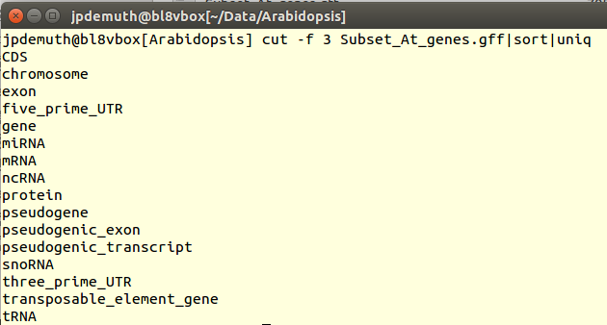
- uniq (in its default format) only keeps lines which are unique in the output

To see what each of the commands is doing try running the cut without sort and uniq, then run again with the cut and the sort (leaving off uniq). What happens if you leave out only the sort command?

U25: sort features in a GFF numerically
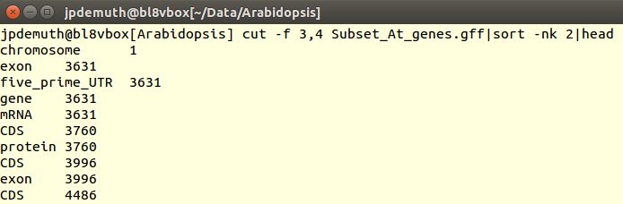
Now let’s imagine that you might want to find which features start earliest in the chromosome sequence. By default, sort will sort alphanumerically, rather than numerically, so we use the -n option to specify that we want to sort “numerically”.
The start coordinate of features is always specified by column 4 of the GFF file, so:

Here we first cut out just the two columns of interest (3 & 4) from the GFF file.

The output is then sorted with the sort command. We have two columns of output at this point and we want sort based on the second column (the start positions). The –k options lets us specify which “kolumn” to sort by and the 2 specifies that we use the second column (note the –nk is the abbreviated method for specifying –n –k).

Finally, we use the head command to get just the default 10 rows of output. These should be lines from the GFF file that have the lowest starting coordinate on chromosome 1.

TASK 25.1 Use the tools you’ve learned so far to determine how many chromosomes are in the Arabidopsis GFF file (including chloroplast and mitochondria).

Two more notes about sort.
- The sort command does not require fields to be cut out of their original lines. For example, see what happens when you execute this command sort -nk 4 Subset_At_genes.gff | head
- Like cut, the sort command’s default delimiter is tab. You can change to any delimiter by including the -t option followed by the character to split lines on. For example sort -nk 3 -t ‘.’ will split lines on each period (.) and sort numerically by the resulting third column.

U26: The right line endings (\n) and the wrong ones (\r)
When you’re in a text editor and you press the return/enter key on your keyboard you may think that this causes the same effect no matter what computer you are using. The visible effects of hitting this key are the same… your cursor moves down one line. However, behind the scenes pressing enter will generate one of two different events (depending on what computer you are using). Technically speaking, pressing enter generates a newline character which is represented internally by either a line feed or carriage return character (actually, Windows uses a combination of both to represent a newline).
If this seems confusing, I’m actually glossing over an even more complex backstory, and if you’re interested there is a good Wikipedia page about it (https://en.wikipedia.org/wiki/Newline). For the purposes of becoming a working bioinformatician, just be aware that modern Mac OSX and Unix/Linux basic text editors use the “right” kind of line endings (\n), while most Microsoft products (Office, Windows) use the “wrong” kind by default (Notepad and other simple text editors in Windows can usually select which kinds of line endings to use).
Unfortunately getting data with the “wrong” line endings is a common bioinformatics headache. It arises when data gets transferred among researchers who have machines running different operating systems (Windows, Mac, Linux) and someone saves the file in a program that uses the wrong kind of line endings.
As you will find out later, interpreting new lines is not always a trivial aspect of developing your own programs to read data appropriately. However, what makes newline characters such a common nightmare for bioinformaticians is that when running a program on data with the wrong line endings, the errors produced are often cryptic and or misleading. Since newline characters are invisible without specifically using a tool to see them, a lot of hours can be lost trying to troubleshoot the program’s code when in fact it is the data that is causing the problem. Potentially even worse… the program might work without telling you there was an error and then the results are wrong.
In Unix (also Python and other programming languages) \n is the “right” kind of line ending used to denote “newlines”. Microsoft software often uses \r. A common fix for this requires substituting \r for \n using tr.

TASK 26.1 Fix the line endings in Data/Misc/excel_data.csv file so that it is one line per sequence.
First use less to view the file. This is a simple 4-line file that was exported from a Mac version of Microsoft Excel. You should see that if you use less, then this appears as one line with the newlines replaced with ^M characters. You can convert these carriage returns into Unix-friendly line-feed characters by using the tr command like so:

U27: Parsing challenge

TASK 27.1 Extract five sequences from intron_IME_data.fasta that are:
- from first introns
- in the 5’ UTR, and
- closest to the TSS.
- output the headers and their corresponding sequence in order of #3.

First look at the data using less or head, just to see what you need to dissect. You should see that every intron sequence in this file has a header line that contains the following pieces of information, each separated by an underscore “_”:
- gene name
- intron position in gene
- distance of intron from transcription start site (TSS)
- type of sequence that intron is located in (either CDS or UTR)

Before you immediately jump to thinking about commands… STOP. Let’s think about this systematically.
First outline how you might accomplish the task if you had to do it without Unix? Outline the steps you would take if you were going to try to extract the correct headers and sequences manually using a text editor.

- Find the headers that indicate the sequence is from the first intron and 5’ UTR
- Take the results from #1 and sort them by distance from TSS
- Keep only the top 5 lowest values from #2

Now start filling in specifics for how to accomplish each step:

- grep for lines with “i1” (first intron) and “5UTR”.
- sort the grep results numerically by the 3rd item in the line (delimited by “_”)
- head -5

At this point you may realize that you can find the right headers to solve the problem, but what about also outputting the sequences?
Hint: could you manipulate line endings to carry headers and their sequences together through the sorting process…

The output for TASK 27.1 should look like this:
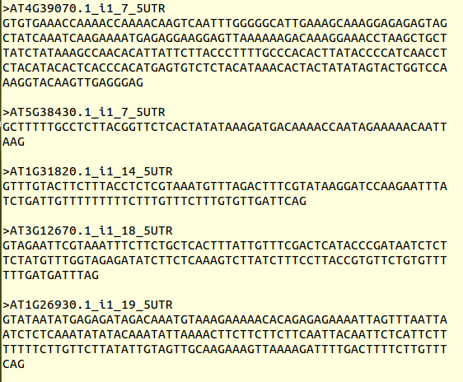

Solution 27.1:
Note that this Unix command is so long that it may appears to wrap across two lines. When you type this, it should all be on a single line (though it may also wrap in the terminal):

tr '\n' '@' < intron_IME_data.fasta | sed 's/>/#>/g' | tr '#' '\n' | grep "i1_.*5UTR" | sort -nk 3 -t "_" | head -5 | tr '@' '\n'

That’s a long command, but it does a lot. Try to break down each step and work out what it is doing. If it isn’t clear, use ChatGPT to help you understand it.
It took seven Unix commands to do this, but these are all relatively simple Unix commands; it is the combination of them together which makes them so powerful. One might argue that when things get this complex with Unix that it might be easier to do it in Python!

U28: When things go wrong
At this point in the course, you may have tried typing some of these commands and have found that things did not work as expected. The most likely explanation is that you made a typing error. “Typo blindness” is a real thing https://www.wired.com/2014/08/wuwt-typos/



In general, if a command fails, check your current directory (pwd) and check that all the files or directories that you mention actually exist as typed. As noted earlier, using tab completion helps with this a lot. Also – believe or not – changing the terminal color scheme can help! The vast majority of errors in the early going will be due to errors in the path and or typos!

